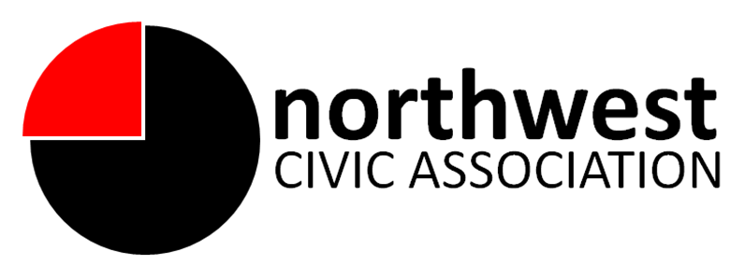

Trustee Responsibilities
Mission Statement:
The mission of the Northwest Civic Association (NWCA) is to promote a positive quality of life, attractive and safe neighborhoods, and a strong economy in northwest Columbus through inclusive community outreach, transparency, and accountability. The NWCA slogan is “Community Enrichment Through Participation."

A NWCA Trustee is a volunteer position serving a two-year term. The NWCA is governed by a board of trustees elected by NWCA members. The Board supports the work of and provides mission-based leadership to members. While day-to-day operations are led by the Board President and Officers, the Board-President relationship is a partnership, and the appropriate involvement of the Board is both critical and expected.

Trustee responsibilities include:

- Serves as a trusted advisor to Board President as necessary
- Is responsible for a specific program area (e.g. zoning, community development, communications/technology, parks and recreation, student trustee program, streets, safety, finance)
- Commits to actively reach out and engage citizens living in the NWCA area to learn of their interests and concerns and recruit members;
- Regularly attends and actively participates in board meetings, important related meetings, and participates in committee work
- Volunteers for and willingly accepts assignments and completes them thoroughly and on time
- Stays informed about committee matters, prepares for meetings including reviewing minutes, pending agenda items and reports
- Becomes familiar with other committee members and collaborates to build a positive working relationship that contributes to consensus
- Is an active participant in the committee's annual evaluation and planning efforts
- Participates in fundraising and other duties that contribute to the benefit of the community
- Represents the NWCA and northwest Columbus community in a professional and positive manner

Preferred qualifications:
Previous experience with:
- non-profit community organizations
- comfortable with various forms of communication (public speaking, electronic communications, social media, etc) as well as conducting research as necessary

Knowledge:
- having an understanding of NWCA, community service, community outreach, willingness to learn and abide by Roberts Rules of Order and basic parliamentary procedures

Abilities/Skills:
- active listening
- ability to work with a diverse population
- ability to identify, articulate and advocate issues expressed by members
- learn new technologies
- work as a team member , i.e., receptive to various forms of feedback

