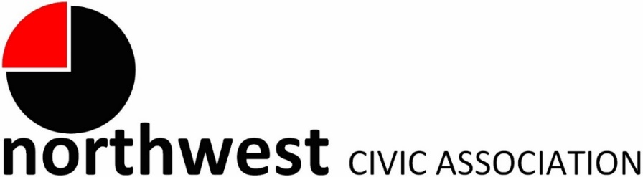

Agenda
Wednesday, April 3, 2024 – 7:00 PM
Northwest Church of the Nazarene (5707 Olentangy River Road) and Zoom

Call to Order/Pledge
Approval of Minutes (Approved during March Trustee meeting)
Treasurer’s Report

Memberships Enrolled in April 2024
Matt Francescon  Doreen Landess | Mary Jo Napoli  M. Jane Pore

Community Mic
A regular meeting segment invites community members to tell us what is on their minds and bring forward ideas for community enhancement.

City Reports
Police Department Liaison: Officer Timothy Montgomery (TMontgomery@columbuspolice.org, 614-645-1417)
Fire Department: Captain Bryan Coffman, (BJCoffman@columbus.gov), or Lt. Michael Fetch (FetchM@columbus.gov)
Neighborhood Liaison: Rebecca Deeds (redeeds@columbus.gov)
Columbus City Council Liaison: Harrison Poku-Yeboah (HAPoku-Yeboah@columbus.gov)

Guest: Representative of the Zoning Code Update Team
Will present an update of the proposed code and its potential impact on the project focus areas within the boundaries of the Northwest Civic Association.

Committee Reports – As needed
- Zoning/Variances – Monica/Zoning Committee
  - Report on recent zoning issues
- Code Enforcement, Streets, and Safety -- Kyle
Old Business
- The Anna Mildred Henderson Award Deadline: May 1 2024
- Trustee Elections in June. Consider applying to join the Board.
New Business
- Community Meeting with Councilperson Wyche, 6:00 pm, April 11th, Lazelle Woods Community Center (8140 Sancus Blvd.)
Adjourn

