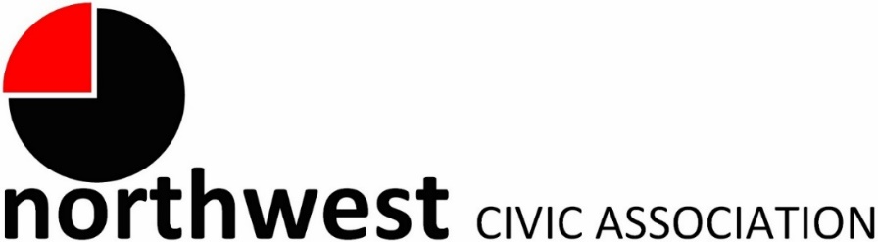

Agenda for Annual Meeting
June 1, 2022 – 7:00 PM
Northwest Church of the Nazarene (5707 Olentangy River Road) and Zoom

Call to Order/Moment of Silence/Pledge
Approval of Minutes
Treasurer’s Report

Membership:
New | Renewals | Associate Membership
Lisa Bycynski | Carla Edlefson | Trotters Chase Condo Assoc.
Mary Jacobs | Dwight Groce | Savko & Sons
John Myers | Todd Hunkins
 | MaryEllen Marrah

City Reports
Police Department Liaison: Officer Duane Hicks (dhicks@columbuspolice.org; 614-645-1417)
Fire Department: Captain Carmelo Gioffre (cvgioffre@columbus.com)
Neighborhood Liaison: Rebecca Deeds (redeeds@columbus.gov)
Columbus City Council Liaison: Harrison Poku-Yeboah (HAPoku-Yeboah@columbus.gov)

Committee Reports – As needed

- West Case Road Park (aka The Sheep Farm) Update – Roy

- Zoning – None tonight
- National Night Out – Save the date! August 2nd at 5707 Olentangy River Rd.

ANNUAL MEETING PROGRAM

- Annual Report for NWCA
- Elections for Trustees
- Enjoy the food

Adjourn

