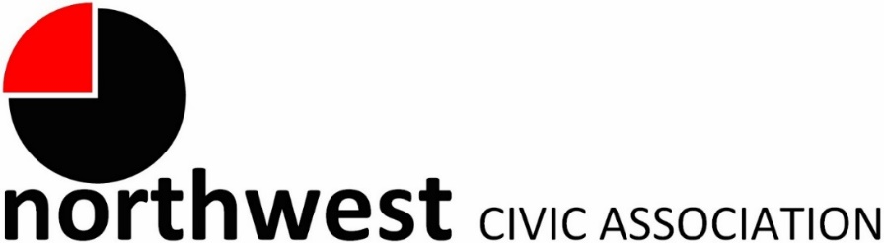

Agenda
November 2, 2022 – 7:00 PM
Northwest Church of the Nazarene (5707 Olentangy River Road) and Zoom

Call to Order/Roll/Pledge
Approval of Minutes
Treasurer’s Report
Membership: none

City Reports
Police Department Liaison: Officer Duane Hicks (dhicks@columbuspolice.org; 614-645-1417)
Fire Department: Captain Carmelo Gioffre (cvgioffre@columbus.com)
Neighborhood Liaison: Rebecca Deeds (redeeds@columbus.gov)
Columbus City Council Liaison: Harrison Poku-Yeboah (HAPoku-Yeboah@columbus.gov)

Guest Speakers: None

Committee Reports – As needed

Old Business
- Call for trustee applications
- Call for volunteers for zoning committee
- Discussion/Q&A of suggested changes to the draft NWCA Code of Regulations

New Business

Adjourn

