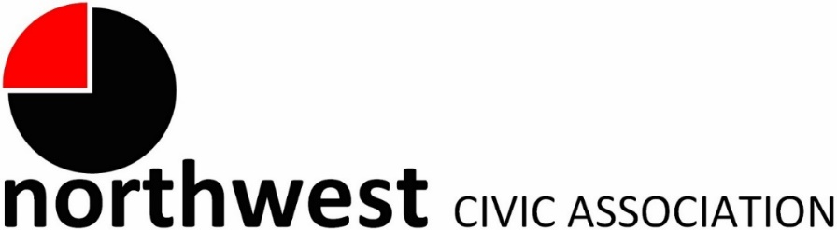

Agenda
Wednesday, November 1, 2023 – 7:00 PM
Northwest Church of the Nazarene (5707 Olentangy River Road) and Zoom

Call to Order/Pledge
Approval of Minutes
Treasurer’s Report
Membership: Jay Shapiro (Associate member)

City Reports
Police Department Liaison: Officer Timothy Montgomery (TMontgomery@columbuspolice.org, 614-645-1417)
Fire Department: Captain Bryan Coffman, (BJCoffman@columbus.gov), or Lt. Michael Fetch (FetchM@columbus.gov)
Neighborhood Liaison: Rebecca Deeds (redeeds@columbus.gov)
Columbus City Council Liaison: Harrison Poku-Yeboah (HAPoku-Yeboah@columbus.gov)

Guest Speaker:
- Missy Rouse – Program Manager, Alzheimer's Association, Central Ohio Chapter will present about the difference in normal aging and signs of Dementia. She will offer information on Free Programs and services available to the Community.

Community Mic
- This is going to be a regular meeting segment to allow community members to tell us what is on their minds and bring forward ideas for community enhancement.

Committee Reports – As needed

- Zoning/Variances – Monica/Zoning Committee
  - Updates on zoning requests
- Code Enforcement, Streets, and Safety

Old Business
New Business
Adjourn

