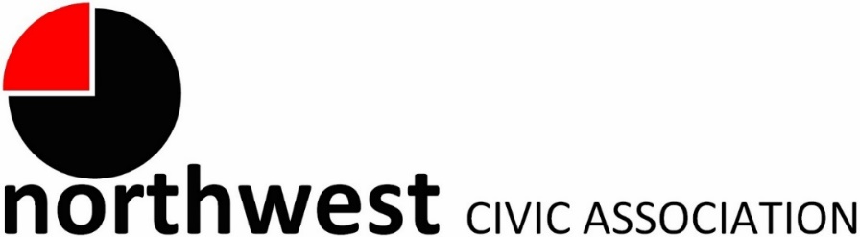

Agenda
Wednesday, March 6, 2024 – 7:00 PM
Northwest Church of the Nazarene (5707 Olentangy River Road) and Zoom

Call to Order/Pledge
Approval of Minutes
Treasurer’s Report

Memberships Enrolled in March 2024
Joe Carter  Friendship Village of Dublin (Associate Member)  Roger Jerome | Michelle Keiter  Larry Miller  Petra Schmalbrock  Dan Schneider | Sheila Seifert  Samuel Simoes  Stacey Swanson

Community Mic
A regular meeting segment invites community members to tell us what is on their minds and bring forward ideas for community enhancement.

City Reports
Police Department Liaison: Officer Timothy Montgomery (TMontgomery@columbuspolice.org, 614-645-1417)
Fire Department: Captain Bryan Coffman, (BJCoffman@columbus.gov), or Lt. Michael Fetch (FetchM@columbus.gov)
Neighborhood Liaison: Rebecca Deeds (redeeds@columbus.gov)
Columbus City Council Liaison: Harrison Poku-Yeboah (HAPoku-Yeboah@columbus.gov)

Guest: Jon Heider, Senior Planner, Mid-Ohio Regional Planning Commission (MORPC)
MORPC leads the region in developing the 2024-2050 Metropolitan Transportation Plan (MTP), which identifies priority transportation infrastructure investments in the central Ohio region for the next 25 years. As part of the plan development process, they will share the strategies and projects proposed to be included in the 2024-2050 MTP.
MORPC Survey about housing: https://www.surveymonkey.com/r/LeadersListenHousing

Committee Reports – As needed
- Zoning/Variances – Monica/Zoning Committee
- Code Enforcement, Streets, and Safety -- Kyle
Old Business
New Business
- The Anna Mildred Henderson Award Deadline: May 1 2024
- Trustee Elections in June. Consider applying to join the Board.
Adjourn

