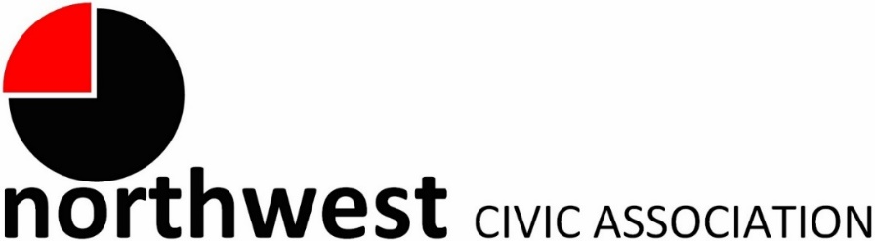

Agenda
Wednesday, January 3, 2024 – 7:00 PM
Northwest Church of the Nazarene (5707 Olentangy River Road) and Zoom

Call to Order/Pledge
Approval of Minutes
Treasurer’s Report
Membership: 2024 memberships

Karen Dimmick  Sherry Girves  Michelle Girves  Marilyn Goodman | Cheryl Grossman  Kyle Hartman  Todd Hunkins  Barbara Limbert | Catherine Logsdon  Sandra Taylor  Paula Thimmes

Community Mic
A regular meeting segment invites community members to tell us what is on their minds and bring forward ideas for community enhancement.

City Reports
Police Department Liaison: Officer Timothy Montgomery (TMontgomery@columbuspolice.org, 614-645-1417)
Fire Department: Captain Bryan Coffman, (BJCoffman@columbus.gov), or Lt. Michael Fetch (FetchM@columbus.gov)
Neighborhood Liaison: Rebecca Deeds (redeeds@columbus.gov)
Columbus City Council Liaison: Harrison Poku-Yeboah (HAPoku-Yeboah@columbus.gov)

Guest Speaker: A representative from Community Refugee & Immigration Services (CRIS) will talk about their services and history. CRIS recently moved into the Northwest Columbus area.

Committee Reports – As needed

- Zoning/Variances – Monica/Zoning Committee
  - Updates on zoning requests
- Code Enforcement, Streets, and Safety

Old Business
New Business
Adjourn

