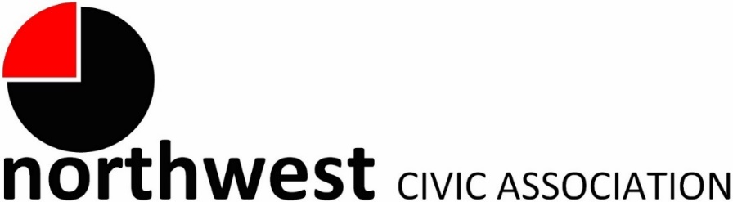

Agenda
July 6, 2022 – 7:00 PM
Northwest Church of the Nazarene (5707 Olentangy River Road) and Zoom

Call to Order/Moment of Silence/Pledge
Approval of Minutes
Treasurer’s Report
Membership:
New | Renewals
James Pickett | Kori Mulligan
Gerald Tankovich
Karen Tankovich

City Reports
Police Department Liaison: Officer Duane Hicks (dhicks@columbuspolice.org; 614-645-1417)
Fire Department: Captain Carmelo Gioffre (cvgioffre@columbus.com)
Neighborhood Liaison: Rebecca Deeds (redeeds@columbus.gov)
Columbus City Council Liaison: Harrison Poku-Yeboah (HAPoku-Yeboah@columbus.gov)

Guest Speaker: Justin Goodman, LinkUS
Update on routing, stop locations, station elements and other Northwest Corridor design elements. Your input will shape tomorrow’s transit.

Guest Speaker: Shiloh Todorov, Development Director, Move to PROSPER
Move to PROSPER gives single moms the chance to access higher-resourced Central Ohio neighborhoods. It’s a three year program that provides rent support that bridges the gap between the lower-resourced neighborhoods where they can afford the rent, and the higher-resourced neighborhoods. During those three years, they get coaching and programs that help them achieve and attain economic stability. In July 2022, we graduate our 10 pilot families, a pilot done in partnership with OSU’s City & Regional Planning school, where the families saw their incomes rise by 58% on average.

Committee Reports – As needed
- National Night Out (NNO)
- Zoning – None tonight

Old Business
New Business
- Election of officers for 2022-23

Adjourn

